# Functional requirements

### Introduction.

In the following section of the report the aim is to outline and explain the functional requirements so what the system will do what it will contain and how it shall work for the Record management system.

## The software features needed within the solution system.

Below is a list of the Software requirements collected from both the interview and the given brief. The functional requirements are laid out clearly below.

* The New system cannot be paper based and must be digital.
* The system should automatically send newsletters, marketing, and emails to customers.
* The codes given to classify the documents should be implemented on the new system.
* There needs to be an internal animal code given to each animal.
* The system should have a login for staff so it's secure and only seniors or top-level administrators should be able to have access to everything and others should be restricted to what they can access.
* Files should easily be able to be shared easily and efficiently through the internet.
* Senior Administrators Need to be able to have full access rights so they need to be able to add, Edit, Delete, Archive all documents.
* Staff need to have Partial access to the Record Management System (RMS). So, they need to be able to edit some files as well as add files.
* Staff should Be able to filter, Search for animals and records based on specific categories.
* There needs to be security measures to protect the data in the RMS.
* All systems will need to be catered for all age groups and types of people.
* The HR system must not be converted.
* Training will need to be offered for the new system, so the staff knows what they're doing.
* Add instructions and a help page in the system to help staff.
* All paper documents need to be easily transferred to a computer system.
* The information and details about the animals such as what they like to eat, habitat etc need to also be stored on the RMS.
* The RMS should have customer emails on where the system will send newsletters/advertisements to the customers.
* Sponsors' data needs to be stored on the RMS in addition they need to be easily accessible.
* There needs to be a progress bar to show you how long you’ll have to wait for uploads.
* All documents should be stored in alphabetical order with the surname as the primary name used.
* The signage needs to be updated yearly so it should be easy to update.
* There needs to be an option on the rms to remove/archive documents as well as permanently deleted.
* The rms needs to hold all the details about the customer such as personal and sensitive data such as contact details and bank details.
* The RMS should have the option to filter sponsors by how long they have left on their sponsor and when they need to renew it.
* The designs for the new signage need to be able to be stored on the RMS and updated through there.
* Updating the documents and sharing need to be an option.
* A form which can be filled out electronically needs to be available so paper documents will not need to be used every time a sponsor wants to sponsor.
* Documents that are more than 2 years old should automatically be destroyed and removed.
* There should be backups of the documents to avoid data loss.
* records management system to send out all the reminders automatically and let him know when renewals come through
* For documents such as the signage you should be able to store drafts, share and make dynamic changes.
* The RMS needs to give notifications when renewals for the sponsors have been made or if they need to be made.
* The RMS should record the income made from sponsorships
* The RMS should record the income made from Memberships.
* The RMS should have a search bar to search for animals, sponsors, and other documents.
* Every document should be given a number relating to their sector such as memberships should be given a membership ID number.
* For the RMS there should be security measures such as encryption, passwords, logins, and security protocols to protect the data.
* The RMS should give a notification if someone is trying to attack the system.
* The RMS needs to comply with the GDPR/FCA.
* Staff need to have training on how to use the RMS.
* There should be a help page.
* Every time a customer becomes a member or books a ticket their information needs to be automatically added to the RMS.
* If a sponsor should be able to becomes a sponsor via a website or other methods. If they become a sponsor through the website their data should automatically be added to the RMS.
* The RMS search criteria should be by animal location, what animals are in a given location, animal name, animal code individual code
* The sponsors should fill out their own forms electronically primarily with the option of doing it by paper and these documents should be directly added once the customer fills out each of their required details.
* The system should have appropriate backups one option could be backing up on a Hard drive however a cloud service would be much better.

## Access Table

Below is an access table to show who can access what parts of the Record management system.

|  |  |  |
| --- | --- | --- |
| Operation | Senior Admin | Staff |
| Add | Create and add new records | No access |
| Delete | Remove/delete records of errors in the RMS. | No Access |
| Archive | Remove records which are no longer needed in the archive section. | No access |
| Amend | Change/edit documents. | Able to edit and amend certain documents. i.e zookeepers can edit and change medical records for an animal. |
| Display | Display all records when a section or document is clicked. | Can display and view documents however the only documents that they need/have access to. i.e zookeepers cannot view customer details. |
| Search | Search for the records needed by typing in the search bar specific record details. | Documents can be searched for by specific information about the required document. i.e animal records can be searched by name or animal identification number. |

## Attributes table.

Below are tables to show the attributes of some of the pages and what each page will contain .As some of the pages are very similar the attribute tables which are below are for the main pages. They highlight the entity so what needs to be entered what format the input should be in as well as an explanation on each entity.

### Login page.

Below is the attribute table for the Login Page.

|  |  |  |
| --- | --- | --- |
| Entity name | Format Type | Notes |
| Username | Integer | A primary key given to staff. |
| Password | Encrypted String | A password for the staff to log in. |
| Forgotten Password | Button | Button to reset password. |

### Animal records.

Below is a attribute table for the animal records. As well as the tables which follow are additional attributes which add on depending on the animal chosen.

|  |  |  |
| --- | --- | --- |
| Entity name | Format/type | Notes |
| Species_Name | String | The specific species name. |
| Animal “given” Name. | String | The name given to the animal for example the low back gorilla name is Redwill. |
| Animal_Code | Integer  Format (6 digits) | A specific animal code given to each animal. |
| D.O.B_Animal. | Integer  Format (6 digits) | The date of birth of the animal. |
| Gender | Boolean | What gender the animal is. |
| Average_Life_Span | Integer | The average life span of the animal which will be in years and months if appropriate. |
| Species_Category/Classification. | String | The specific classification/category of the species. |
| Dietary_Requirements. | String | The dietary habits of the animal. |
| Natural_Habitat_Description. | String | The natural habitat of the animal |
| Global_Population_Distribution. | Integer | The global distribution of the animal. |
| Date_animal_joined. | Integer | This is the date the animal joined the zoo. |
| Typical_animal_dimensions | Decimals | The typical dimensions of the animal which will consist of things like height,weight. |
| Picture of Animal | JPEG | The image of the animal |

### Specific species Birds

|  |  |  |
| --- | --- | --- |
| Entity name | Format/Type | Notes |
| Nest_Construction_Method. | String | How the bird constructs the nest. |
| Clutch_size. | Decimal | The clutch size of the birdwhich will be measured in cm. |
| Wing_span. | Decimal | The wingspan of the bird in cm. |
| Ability_to_Fly | Boolean | Can the animal fly this will be a yes or no option. |
| Plumage_colour_variants. | String | The colour variants of the bird. |

### Specific species fish

|  |  |  |
| --- | --- | --- |
| Entity name | Format/Type | Notes |
| Average_body_temperature. | Decimal | The average body temperature of the fish. |
| Water_type. | String | What water type the fish lives in eg salt water or clear water. |
| Colour_variants | String | What colour variants there are of the fish. |
| Gender | String | The gender of the fish if applicable. |

### Reptiles’ amphibians

|  |  |  |
| --- | --- | --- |
| Entity name | Format/Type | Notes |
| Reproduction type. | String |  |
| Average Clutch Size. | Decimal |  |
| Average number of offspring. | Integer |  |

### Mammals

|  |  |  |
| --- | --- | --- |
| Entity name | Format/Type | Notes |
| Gestational_Period. | Decimal | The Gestational period of the animal. |
| Mammal_Category | String | The mammal category the mammal belongs to. |
| Average_body_temperature. | Decimal | The average body temperature of the mammal. |

### Sponsor Page

Below is the entity table for the sponsor page.

|  |  |  |
| --- | --- | --- |
| Entity name | Format/Type | Notes |
| Client/Company_Name | String | The client or company name of the sponsor. |
| Existing_Customer | Boolean | Is the sponsor a current customer at the zoo. |
| ID | Integer | The ID number to be given to the sponsor. |
| Primary_Telephone_Number | Integer | The primary phone number of the sponsor. |
| Secondary_Telephone_Number | Integer | The secondary/backup phone number of the sponsor. |
| Client_Address/Contact_Details | String | The client address and the contact details such as an email. |
| Animal(s)_sponsored | String | The animal/animals to be sponsored. |
| Animal_location | Integer | The location of the animal which will be sponsored. |
| Sponsorship_Band | Boolean | Which sponsor option the sponsor has chosen the sponsor bands are from A-E |
| Total_Price | Decimal | The total annual price the sponsor option costs. |
| Period_of_agreement | Integer | How long the sponsor will be sponsoring the animal for. |
| Special_Notes/Requests | String | Any additional notes or requests the sponsor wants from the Zoo. |
| Customer_Agreement | String | The customer agreement form that the sponsor reads and fills out. |
| Payment_Details | Integer | The payment details for the sponsor. |
| Payment_Received | Boolean | Was the payment received this is a yes or no option which is a drop-down box. |
| Sponsorship_Review_Date | Integer | The sponsor review date when the sponsor needs to review the sponsor. |
| Signed/Date | String | Date and signed by the sponsor. |

### Membership Record.

Below is the entity table for a membership.

|  |  |  |
| --- | --- | --- |
| Entity name | Format/Type | Notes |
| First_name | String | The first name of the member. |
| Last_name | String | The last name of the member. |
| Membership_ID | String | The membership ID given for the member. |
| Company_name (optional) | String | The company name if there is one for the member. |
| Country / Region | String | The country/region that the member is lives in. |
| Street_address | String | The street address of the member. |
| Postcode | String | The postcode of the member. |
| Phone | Integer | The phone number of the member. |
| Email_address | String | The email address of the Member. |
| Date_Joined | Integer | The date the customer became a member. |
| Membership_Type | String | The type of membership. |
| Renewal_Date | Integer | The renewal date for the member. |
| Payment_Method | String | The payment method of the membor. |
| Picture | JPEG | A picture of the member to put on the Membership card. |

## Software data input details/format and associated error messages.

Below are tables for some of the main pages which show how they work as well as what inputs are required and if the error messages which will be shown if an incorrect input is entered.

### Login page

|  |  |
| --- | --- |
| Page | Records Management System – Login Page |
| Functionality Description | This page allows authorised personnel to login to the RMS.  Additionally This page allows:   1. A request password reset |
| Page Inputs | The page displays these input fields:   1. Username 2. Password   Once these fields are entered the user can <Log In> to login to the RMS.  Also the page Displays a <Reset Password> option. |
| Operation/Error Messages | The Login Page gives error messages Based on the credentials which are entered if they are wrong this also checks access. All login pages will be the same. After 3 attempts if the login details are entered incorrectly the login is blocked and a number to call is shown: -   |  |  |  | | --- | --- | --- | | Username | Password | Message/Output/Action | | Correct | Correct | Successful access to main user dashboard –**Screen/Page: EN-RMS-02 – Home Page** | | Incorrect | Correct | Error message "Incorrect Log in - <Reset Password> to change password" | | Correct | Incorrect | Error message "Incorrect password - <Reset Password> to change Password" | | Incorrect | Incorrect | Error message "Unknown username and/or password - <Reset Password> for support" | | Incorrect x3 | Incorrect x3 | Error message ”Locked please call 0800221541 or Contact senior admin” - | |
| Confirmation/feedback Messages | The system provides a Confirmation to say Login has been successful.  “Welcome [Name]” |
| Additional Outputs | If the client selects <Reset Password> the system takes the user to the page **EX-RMS-07 – Reset Password Page** |

### Animal Page

|  |  |
| --- | --- |
| Page | Records Management System – Animal Page |
| Functionality Description | This page shows all the animals.  Additionally, this page allows:   * Search for animal * Filter for animal * View animal * Add To animal * Remove * Edit animal * Return to home page * Change pages. |
| Page Inputs | The page displays these input fields:   * Animal details Such as name, ID etc..   Once these fields are entered the user can <Search Animal> to find a animal.  Also the page Displays <Animal Records> To view all animals.. |
| Operation/Error Messages | If nothing is found due because credentials are entered a message will be shown “Nothing found”:-   |  |  | | --- | --- | | Search | Message/Output/Action | | Correct | Successful search filters all the animal information and shows the animal searched – **Screen/Page; EN-RMS-04.01-Animal page** | |  |  | | Incorrect | Incorrect search “**Nothing found**”. | |
| Confirmation/feedback Messages | Once a animal is chosen user is taken to **Screen/Page; EN-RMS-04.1-Animal page** |
| Additional Outputs | **n/a** |

### Animal page 2 for specific animals:

|  |  |
| --- | --- |
| Page | Records Management System – Login Page |
| Functionality Description | This page allows authorised personnel to View specific animal records it will have all their details on.  Additionally, this page allows:   * Editing Animal Information * Editing signage * Save information * Remove files * Add new sections |
| Page Inputs | The page displays these input fields:   * Search * Species Name * Animal “given” Name. * Animal Code * Date of Birth of Animal. * Gender. * Average Life Span. * Species Category/Classification. * Dietary Requirements. * Natural Habitat Description. * Global Population Distribution. * Date animal joined the zoo. * Typical animal dimensions. * Picture of Animal * Gestational Period. * Mammal Category * Average body temperature.   If the user decided to search for a new animal the user types in the <search bar> and are taken to another page.  If any of these fields are entered the user can click <Save> to save all the updates and changes. |
| Operation/Error Messages | The animal page will give error message “Invalid Input” if the incorrect format is typed or option is chosen.   |  |  | | --- | --- | | Format for entity | Message/Output/Action | | Correct | Successful input no error updated. | | Incorrect | Error message "Incorrect Format should be numerical only - <Re enter> in numerical only " | |
| Confirmation/feedback Messages | The system provide a Confirmation to say that the File has been updated “Successfully saved”. |
| Additional Outputs | n/a |

## Software processing logic.

In this section Flowcharts have been used to show how to view files and edit them and how to create and add new files ass the format is the same for every other page such as membership sponsor the examples below are just for the animal page however the format for the other pages are identical.

### Add New document.

### View files for the animal and edit/change.

## Emails

Below are emails examples of emails which will be sent to staff aswell as customers addressing certain issues.

### Reset Password.

Below is an email sent to staff to Reset their password.

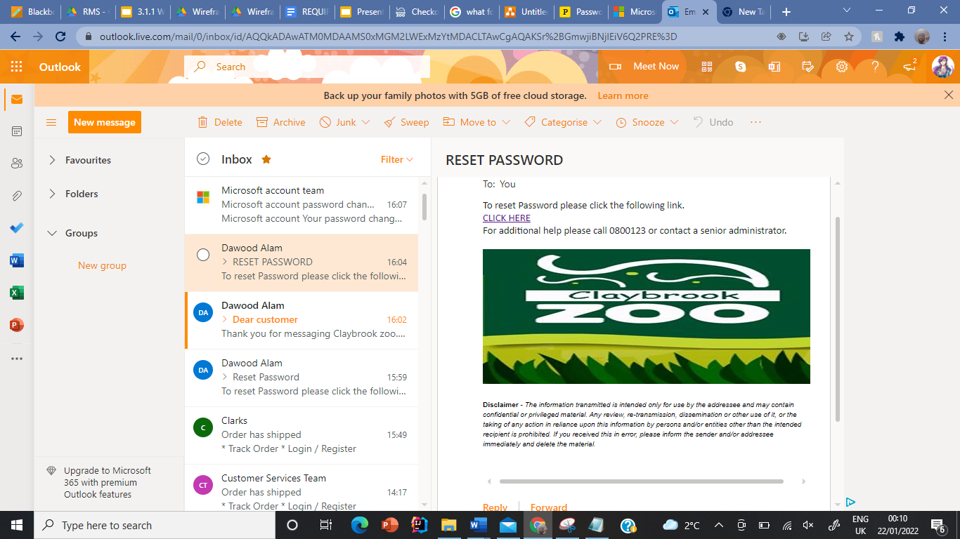

### Customer question email.

Below is an email sent to a customer once they have filled out a contact us form on the website.

